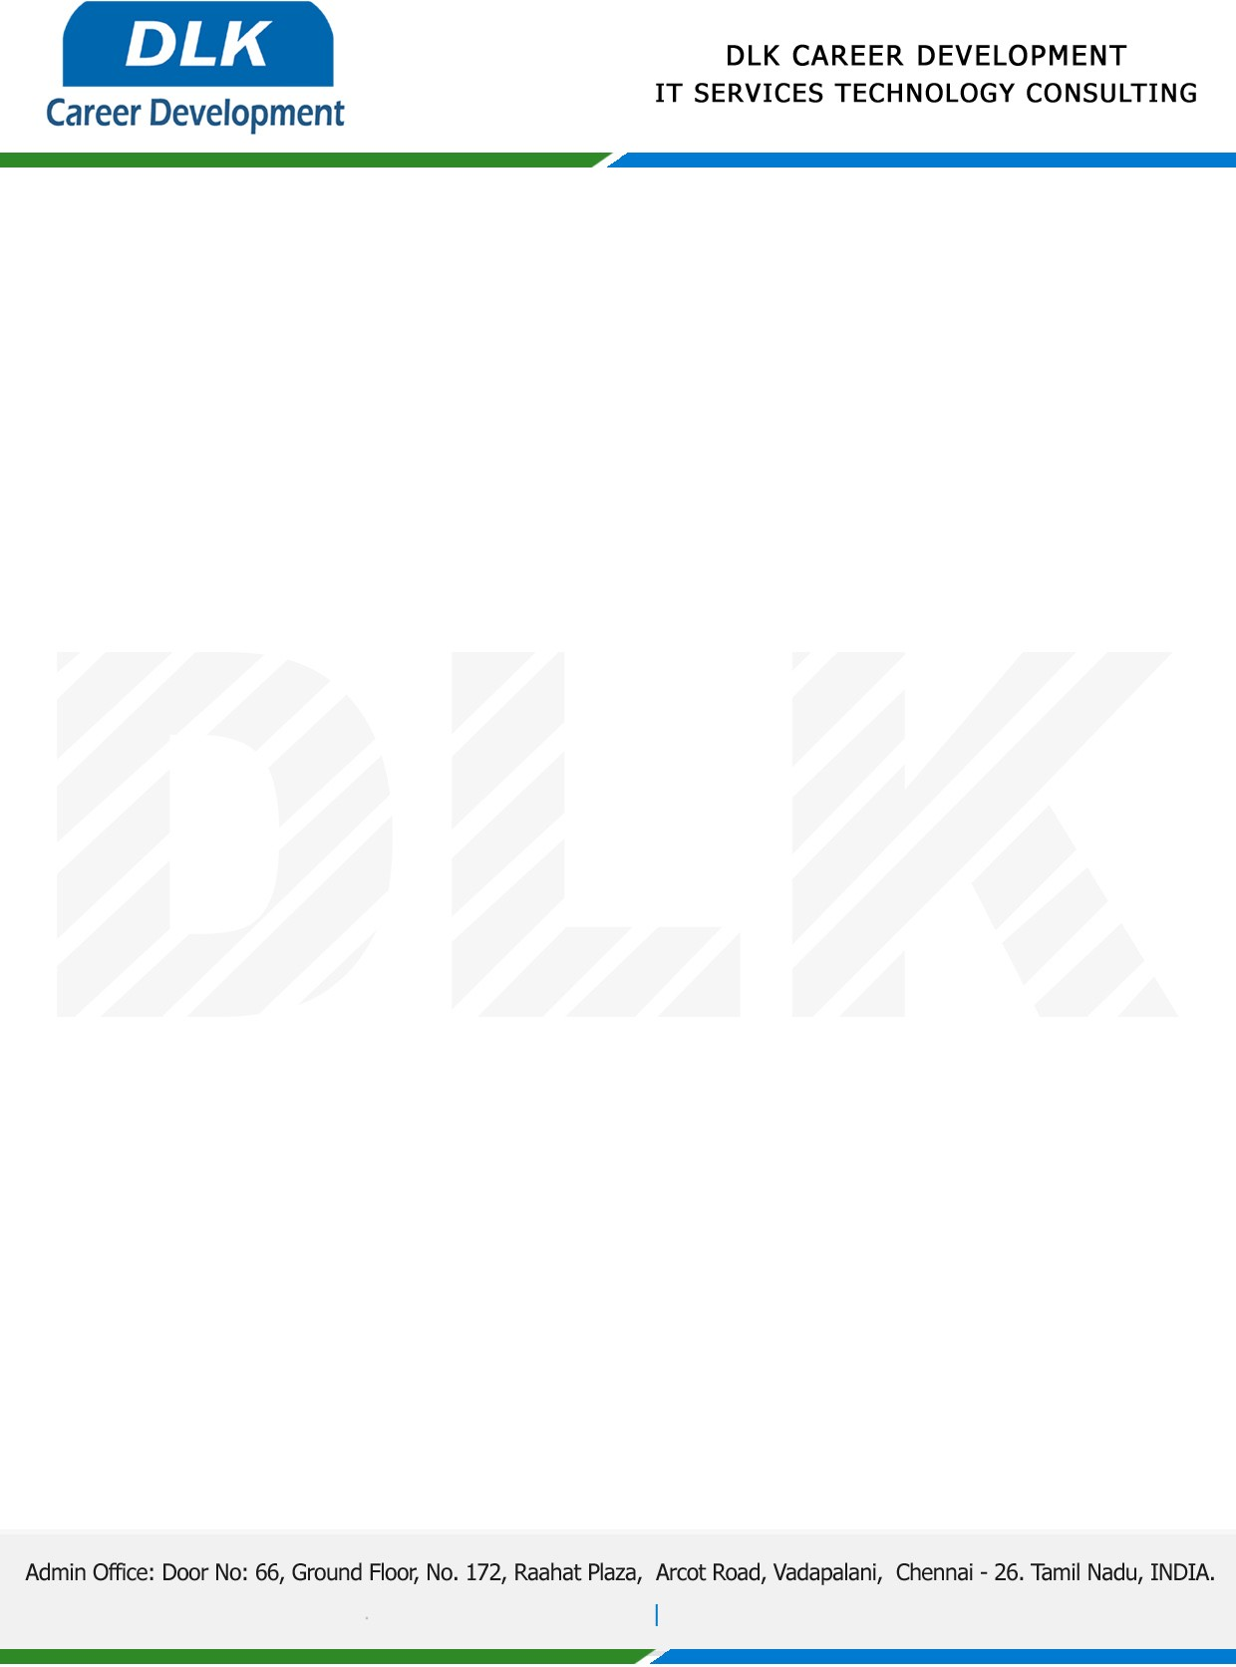

Date: 03 / January / 2022

**To**

Department of MBA ([Human Resource),](https://www.cseindia.org/)

Head of Department,

Vels Institute of Science, Technology & Advanced Studies, Chennai - 600117.

**Sub: Letter of Project Acceptance**

This is to certify that **MR KEERTHIVASAN S (REG NO: 41410169)** that final year student of has accepted his Project Work duration from **05th January 2023** to **01st May 2023** under the domain **“Human Resource”.** During the internship, all information and data collected from you should be kept confidential.

**Topic:** A Study on Job Satisfaction and HR Management on Employees of DLK Company in Chennai

We appreciate your interest in **DLK CAREER DEVELOPMENT**

